Title of Full Paper (Capitalize each Word)
First name Last name (first author)& First name Last name (second author)
Affiliation (Department of Taxation, Federal Polytechnic, Ilaro, Ogun state, Nigeria)
First.Author@institution.org; Second.Author@institution.org
Phone Number

Abstract
In this paper, the formatting requirements for the JOWITED, Ilaro chapter, The Federal Polytechnic, Ilaro, Ogun State, Nigeria are described. Some recommendations on writing for a worldwide readership are offered. Please review this document to learn about the formatting of text, table captions, references, and the method to include the indexing information. The Accepted Manuscript will be published in an electronic format and referenced in Google Scholar Database. The full paper in MS Word file shall be written in compliance with these instructions. At a later stage, it will be converted into Portable Document Format (PDF). An abstract not between 200 to 300 words and should appear on the top of the first page, after the title of the paper in a section titled "Abstarct" after the names of the authors.
Keywords: 3-5 keywords
1.0 About the Author
It is expected that authors will submit carefully written and proofread material. Careful checking for spelling and grammatical errors should be performed. The number of pages of the paper should be between 4 and 8. Papers should clearly describe the background of the subject, the authors work, including the methods used, results and concluding discussion on the importance of the work. Papers are to be prepared in English and SI units must be used. Technical terms should be explained unless they may be considered to be known to the conference community.
Conclusion/Recommendations should state concisely the most important propositions of the paper as well as the author’s view of the practical implications of the results.
2.0 Paper Format
The uniform appearance will assist the reader to read article in the Journal. It is therefore suggested to authors to use the example of this file to construct their papers. This particular example uses an American letter format with 25 mm margins left, right, top and bottom. All text within Abstract should be single spaced while other texts within the body should be 1.15. Spaces should be used to separate paragraphs.
Conclusions/Recommendations should state concisely the most important propositions of the paper as well as the author’s views of the practical implications of the results.

Footer
The footer shows Journal details. Do not include anything here.

Fonts
Papers should use 10-point Times New Roman font. It is recommended that text in figures should not smaller than 10-point font size. However, title of paper should be 14 points and bold, Names of Authors should be 12 points and bold while affiliation should be 10 pints.

Tables and Figures
Figure captions and table headings should be sufficient to explain the figure or table without needing to refer to the text. Figures and tables not cited in the text should not be presented. The following is an example for Table 1.

Table 1: Title of the Table
Type of nanoparticles | Average size (nm) | Variance (nm)
CuO | 47 | 4.2
Nio | 35 | 6.4
Al₂O₃ | 42 | 2.1
SnO₂ | 27 | 3.9

Tables and figures should be placed close after their first reference in the text. All figures and tables should be numbered with Arabic numerals. Table headings should be centred above the tables. Figure captions should be centred below the figures as shown in Figure 1. The source of all tables and figures must be properly stated below the tables and figures.
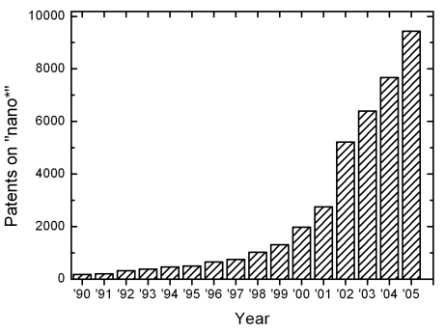
Figure 1: Number of patents on nanotechnology with time

Equations
Each equation should be presented on a separate line from the text with a blank space above and below. Equations should be clear, develop using Equation Editor and expressions used should be explained in the text. The equations should be numbered consecutively at the outer right margin, as shown in Eqs. (1) - (3) below. Here is one example.
In this case, the governing system of equations can be written as follows:
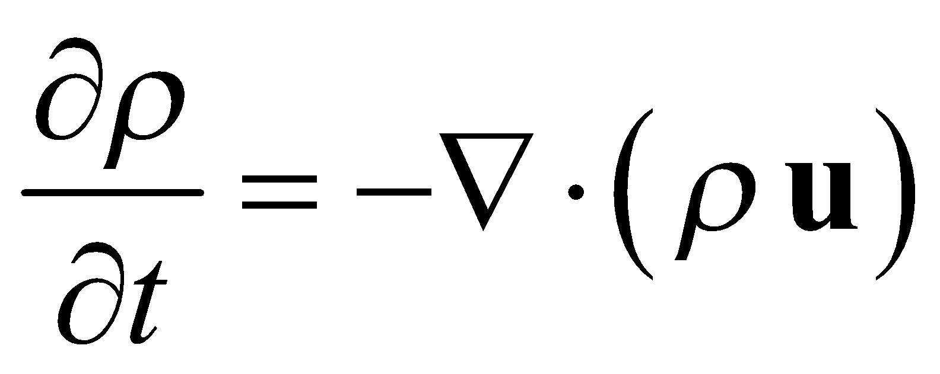 (1)
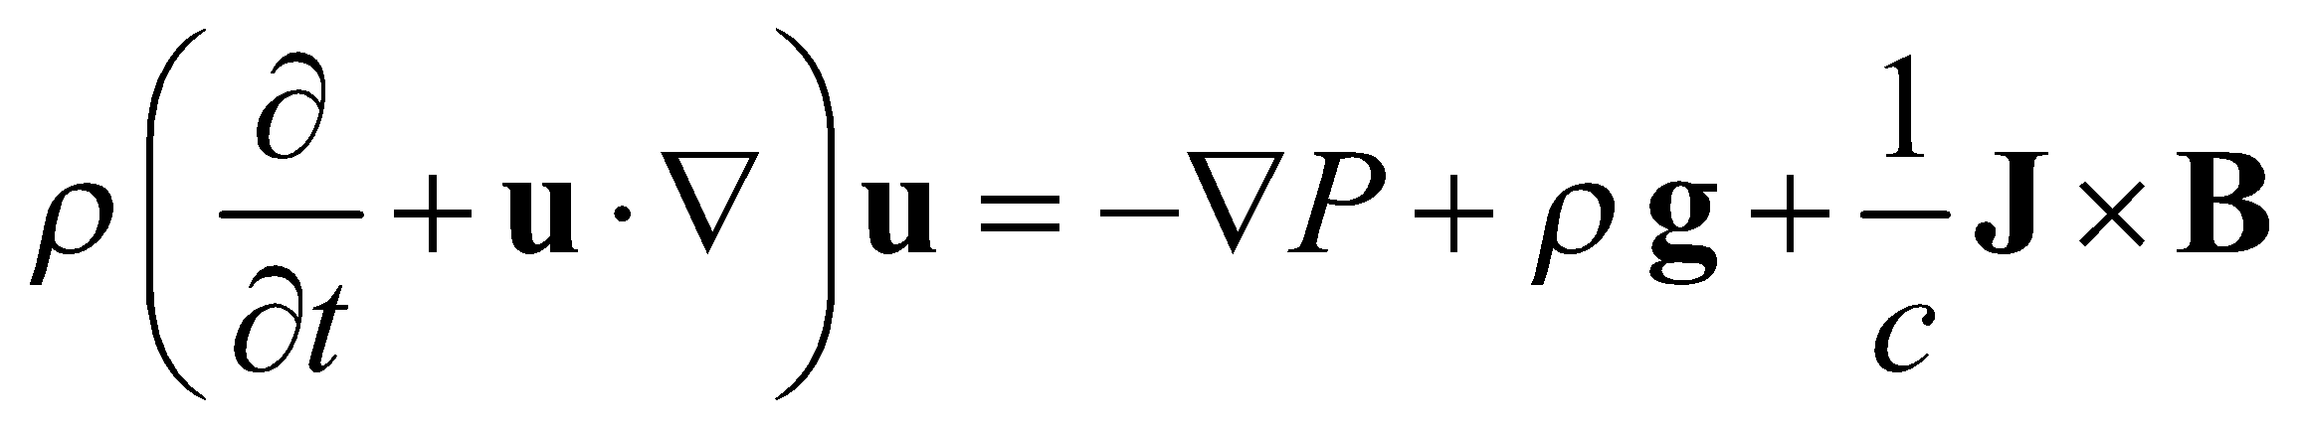 (2)
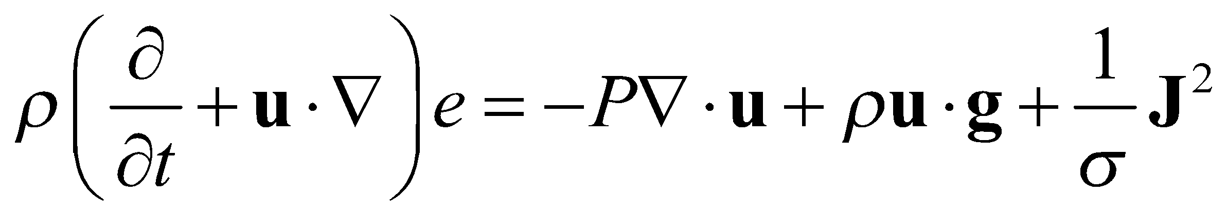 (3)

3.0 Referencing
In-text references must be properly carried out and the list of references provided according to 7th Edition of APA Style of Referencing.
4.0 Acknowledgement (If Applicable)
A short acknowledgement section can be written between the conclusion and the references. Sponsorship and financial support acknowledgments should be included here. Acknowledging the contributions of other colleagues who are not included in the authorship of this paper is also added in this section. If no acknowledgement is necessary, this section should not appear in the paper.
5.0 Submitting the Paper
The full paper has to be submitted electronically to the Journal email: fpiwitedjournal2020@federalpolyilaro.edu.ng (email for the journal to be used).
6.0 Journal Publication
The journal will be published online with article refenced in google scholar
References
Journals
Storey, J. D. (2002). A direct approach to false discovery rates, Journal of the Royal Statistical Society, 64(3):479–498

Jun, S., Rho, S., and Hwang, E. (2010). Music retrieval and recommendation scheme based on varying mood sequences. International Journal on Semantic Web and Information Systems (IJSWIS), 6(2):1-16

Books
James, G., Witten, D., Hastie, T. and Tibshirani, R. (2013). An introduction to statistical learning with application in R. New York: Springer.

Hajez, H. and Karaman, R. (2015). Drug Overview in Commonly Used Drugs. Nova: Nova Science publisher

Chapter Contribution in a Book
Hoskins, S. P., Shyr, D., and Shyr, Y. (2017). Sample Size Calculation for Differential Expression Analysis of RNA-Seq Data. In Frontiers of Biostatistical Methods and Applications in Clinical Oncology (pp. 359-379), Springer, Singapore

Conference Proceedings
Andersen, R., Gleich, D.F., and Mirrokni, V. (2012). Overlapping clusters for distributed computation. In Proceedings of the fifth ACM international conference on Web search and data mining (pp. 273-282).

Web Reference
NIH. (2015, December 10). National Institutes of Health. Retrieved 5 July 2009 from: http://www.nih.gov/.

